**Project Increment-2**

**Team members (PG-7)**

Oshani Titti (12443220)

Ram Shasank Pathath (16183838)

Mohan Krishna Doddala (16201768)

**Design**

In our previous increment we tried to implement basic requirements like sing, dance, make a call, send text message, and color detection. In this increment we implemented face recognition and gesture recognition through socket connection.



Since our project I-translator is mainly useful while travelling to different places, we tried to implement the mongo db for storing the places that you like in different categories like parks, museums etc. We tried to retrieve the stored data from the database while selecting the category but we are facing implementation issues and could not complete this. This feature will of great help to the users as they can store the visited places along with a short description and a picture which can be viewed later. This not only acts as storage for list of visited places but also a memory and whenever the user visits the same place or country again he can check out his favorite places from the database very easily.

**Features**

* Face recognition- This feature will help the robot to capture the face of a particular person and it detects that person’s face and gives the similarity percentage of the detected face. We even tried implementing to greet the person if the similarity percent is greater than 80% assuming that he will be the regular user of the app but we are facing some issues in the code.

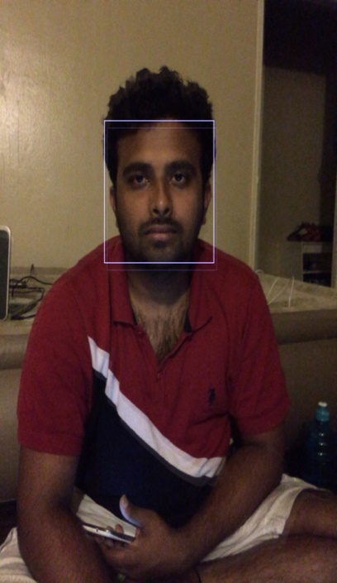



* Gesture recognition- This feature is implemented using peer-to-peer collaboration. Depending upon the movement of your hand, robo me will move. This is implemented using socket programming.
* Mongo DB- We used IntelliJ to store the data in mongo db and tried retrieving it whenever a question is asked. We used Google maps api for implementing this particular feature. Whenever you visit a place and if you like it, you can store the place along with description and photo. This can be retrieved from database.

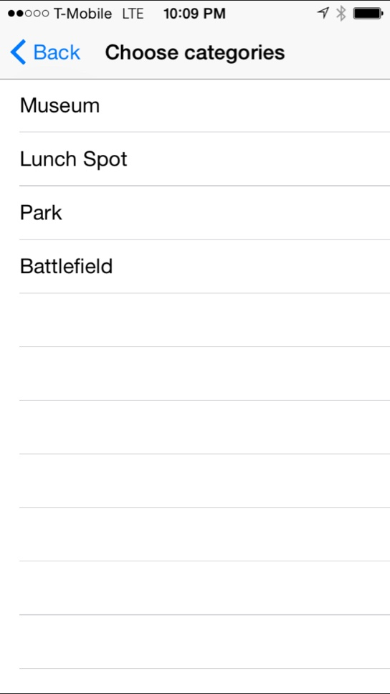

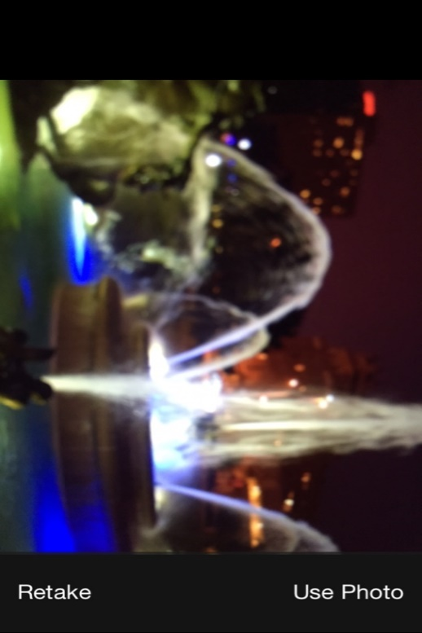

You can take the photo of the location and store it along with the description and category.

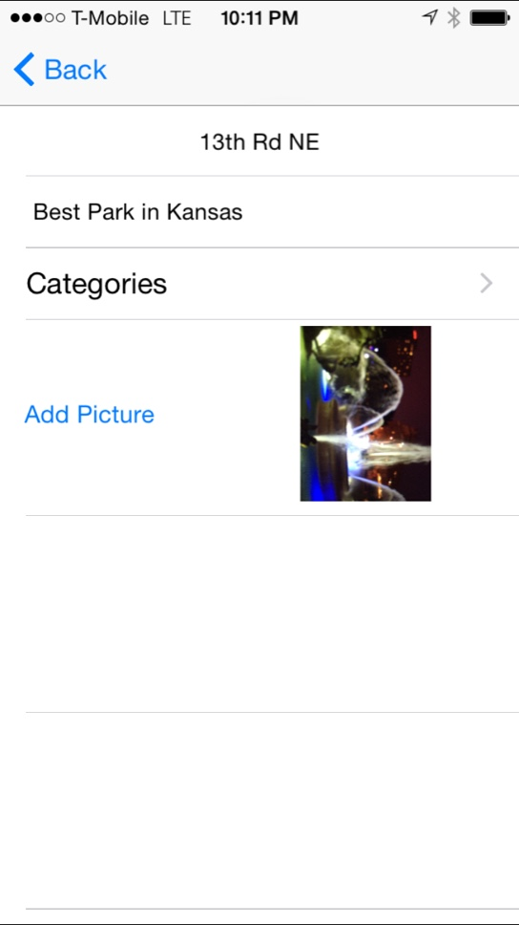

**Resources**

<http://140dev.com/?s=search+api>

<http://stackoverflow.com/questions/14979633/twitter-search-api-always-return-15-tweets?rq=1>

<http://docs.mongolab.com/languages/>

<http://www.raywenderlich.com/61078/write-simple-node-jsmongodb-web-service-ios-app>